2i2D / ETLV | Objectif : Décrire le principe du mur Trombe en anglais  Lire les textes ci-dessous - Rechercher et apprendre le vocabulaire. | DT02

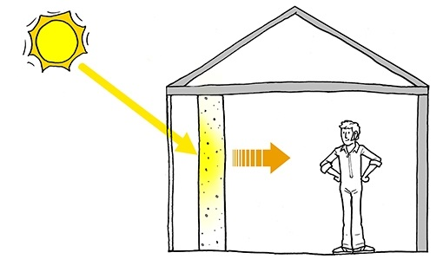 | A Trombe wall is a system for indirect solar heat gain⁽¹⁾ and, although not extremely common, is a good example of thermal mass⁽²⁾, solar gain, and glazing properties used together to achieve human comfort goals passively⁽³⁾.  It consists of a dark colored wall⁽⁴⁾ of high thermal mass facing the sun⁽⁵⁾, with glazing spaced in front⁽⁶⁾ to leave a small air space. The glazing traps solar radiation⁽⁷⁾ like a small greenhouse⁽⁸⁾. | ⁽¹⁾ ______________________________________  ⁽²⁾ ______________________________________  ⁽³⁾ ______________________________________  ⁽⁴⁾ ______________________________________  ⁽⁵⁾ ______________________________________  ⁽⁶⁾ ______________________________________  ⁽⁷⁾ ______________________________________  ⁽⁸⁾ ______________________________________  ⁽⁹⁾ ______________________________________  ⁽¹⁰⁾ ______________________________________  ⁽¹¹⁾ ______________________________________  ⁽¹²⁾ ______________________________________  ⁽¹³⁾ ______________________________________  ⁽¹⁴⁾ ______________________________________  ⁽¹⁵⁾ ______________________________________  ⁽¹⁶⁾ ______________________________________  ⁽¹⁷⁾ ______________________________________  ⁽¹⁸⁾ ______________________________________  ⁽¹⁹⁾ ______________________________________  ⁽²⁰⁾ ______________________________________  ⁽²¹⁾ ______________________________________  ⁽²²⁾ ______________________________________  ⁽²³⁾ ______________________________________  ⁽²⁴⁾ ______________________________________  ⁽²⁵⁾ ______________________________________  ⁽²⁶⁾ ______________________________________  ⁽²⁷⁾ ______________________________________  ⁽²⁸⁾ ______________________________________  ⁽²⁹⁾ ______________________________________  ⁽³⁰⁾ ______________________________________  ⁽³¹⁾ ______________________________________  ⁽³²⁾ ______________________________________  ⁽³³⁾ ______________________________________  ⁽³⁴⁾ ______________________________________  ⁽³⁵⁾ ______________________________________  ⁽³⁶⁾ ______________________________________  ⁽³⁷⁾ ______________________________________  ⁽³⁸⁾ ______________________________________  ⁽³⁹⁾ ______________________________________  ⁽⁴⁰⁾ ______________________________________
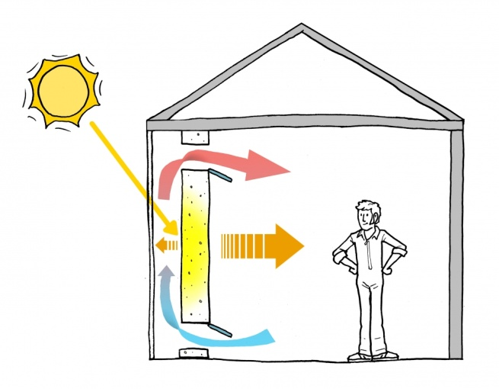  A vented Trombe wall heats air convectively as well as heating the space radiatively.  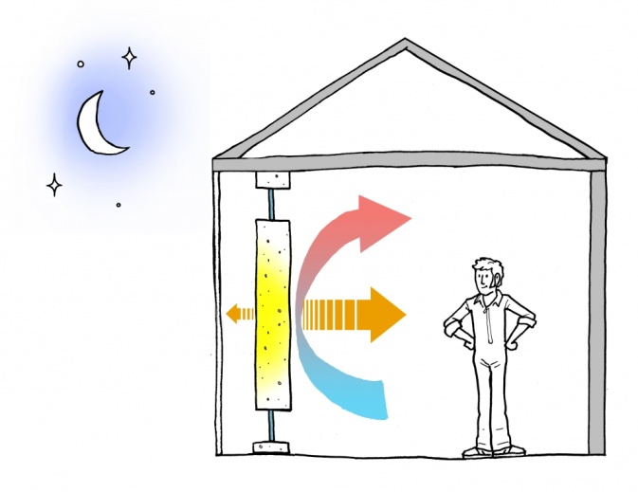  Vents can be shut at night to keep the convection loop moving the right direction. | Trombe walls are a very useful passive heating system⁽⁹⁾. They require little or no effort to operate⁽¹⁰⁾, and are ideal for spaces where silence and privacy are desirable. Rooms heated by a Trombe wall often feel more comfortable than those heated by forced-air systems⁽¹¹⁾, even at lower air temperatures, because of the radiantly warm surface of the wall⁽¹²⁾.  A successful Trombe wall or attached sunspace optimizes⁽¹³⁾ heat gain and minimizes heat loss during cold times⁽¹⁴⁾, and avoids excess heat gain⁽¹⁵⁾ in hot times.  Trombe walls are thermal storage walls⁽¹⁶⁾, named after the French inventor⁽¹⁷⁾ Felix Trombe. A typical Trombe wall consists of a 20 – 40 cm thick masonry wall painted a dark⁽¹⁸⁾, heat-absorbing color and faced with a single or double layer of glass⁽¹⁹⁾. The glass is placed between 2 - 15 cm away from the masonry wall to create a small airspace⁽²⁰⁾. Heat from sunlight passing through the glass is absorbed by the dark surface, stored in the wall, and conducted slowly inward⁽²¹⁾ through the masonry.  The glass prevents the escape of radiant heat from the warm surface of the storage wall. The heat radiated by the wall is therefore trapped within the air gap⁽²²⁾, further heating the wall surface. For a 40cm thick Trombe wall, heat will take about 8 to 10 hours to reach the interior of the building⁽²³⁾. This means that the room behind remains comfortable through the day and receives slow, even heating⁽²⁴⁾ for many hours after the sun sets. Such designs are ideal for use in⁽²⁵⁾ residential living areas and bedrooms.  In addition to radiant heat, you can also configure Trombe walls to heat air within the internal space⁽²⁶⁾. Including upper and lower air vents⁽²⁷⁾ in the wall allows convection currents⁽²⁸⁾, as cooler air⁽²⁹⁾ from the room enters at the bottom⁽³⁰⁾ and air heated in the Trombe wall escapes into the room at the top⁽³¹⁾. These vents must be operable⁽³²⁾ to prevent reverse convention currents occurring at night, which would cool the occupied space. Operable vents also allow the occupants control over instantaneous heating.
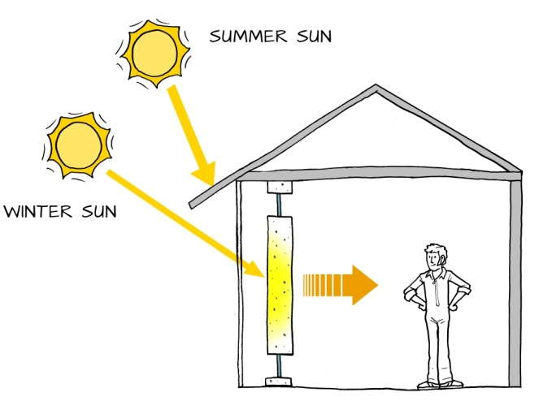  A Trombe wall with overhang to shade from summer sun | Adapting to Day & Season  To avoid overheating⁽³³⁾ at hot times of day or hot seasons of the year, architects can use Trombe walls in conjunction with overhangs, eaves⁽³⁴⁾, and other building design elements to evenly balance solar heat delivery.  Ideally, the glazing should have exterior insulating shutters⁽³⁵⁾ for nighttime use in order to prevent the heat gained from being returned back to the outside.
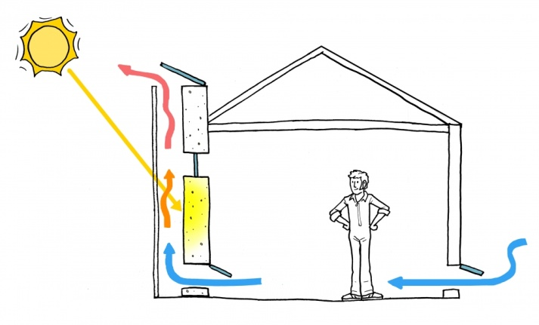A Trombe wall acting as a solar chimney | Solar chimney  During hot seasons⁽³⁶⁾, a Trombe wall with vents through it can be used as a thermosiphon⁽³⁷⁾. If vents are placed at the top of the glazing, then air from the room will be pulled out by convection in the air gap⁽³⁸⁾ between glazing and mass wall. This form of passive ventilation⁽³⁹⁾ is called a solar chimney⁽⁴⁰⁾.
Source : Trombe Wall and Attached Sunspace Part-1 | Search | Autodesk Knowledge Network

