**DOCUMENTS RÉPONSES À RENDRE AVEC LA COPIE**

**Partie 2 - Sciences Physiques**

**Document réponses DR-SP1 (Q46).**

**Document réponses DR-SP2 (Q51).**

**Document réponses DR-SP3 (Q60).**

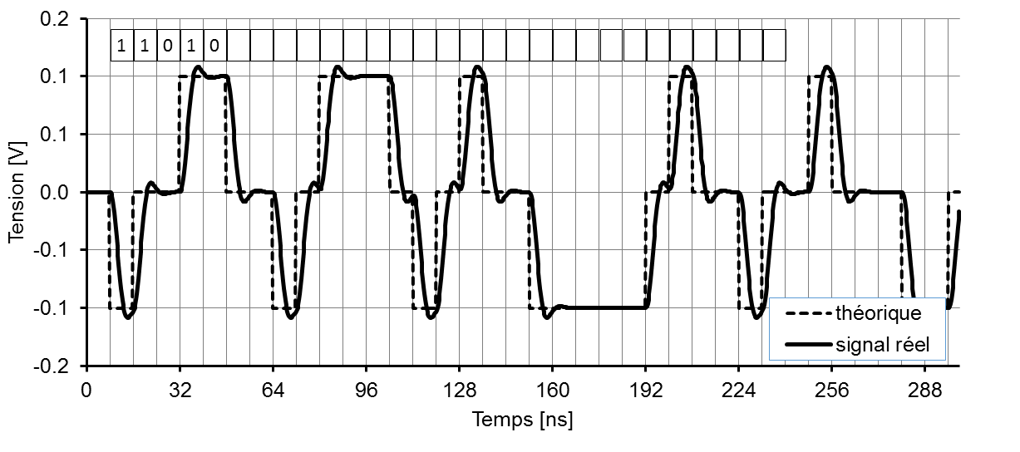

{dk}

**Document réponses DR-SP4 (Q61).**

|  |  |  |  |  |  |  |  |  |  |  |  |  |  |  |  |  |  |  |  |  |  |
| --- | --- | --- | --- | --- | --- | --- | --- | --- | --- | --- | --- | --- | --- | --- | --- | --- | --- | --- | --- | --- | --- |
| **k** | 0 | 1 | 2 | 3 | 4 | 5 | 6 | 7 | 8 | 9 | 10 | 11 | 12 | 13 | 14 | 15 | 16 | 17 | 18 | 19 | 20 |
| **bk** | 0 | 1 | 0 | 2 | 8 | 1 | 0 | 0 | 6 | 0 | 1 |  |  |  |  |  |  |  |  |  |  |
| **b’k** | 0 | 1 | 0 | 0 | 0 | 1 | 0 | 0 | 0 | 0 | 1 |  |  |  |  |  |  |  |  |  |  |

**Document réponses DR-SP5 (Q62) : ek=dk xor b’k**

|  |  |  |  |  |  |  |  |  |  |  |  |  |  |  |  |  |  |  |
| --- | --- | --- | --- | --- | --- | --- | --- | --- | --- | --- | --- | --- | --- | --- | --- | --- | --- | --- |
| **dk** | 0 | 0 | 1 | 0 | 0 | 0 | 1 | 1 | 1 | 1 | 0 | 1 | 0 | 1 | 1 | 1 | 1 | 0 |
| **b’k** | 1 | 0 | 1 | 0 | 0 | 1 | 0 | 0 | 0 | 1 | 0 | 0 | 0 | 1 | 1 | 0 | 1 | 0 |
| **ek** |  |  |  |  |  |  |  |  |  |  |  |  |  |  |  |  |  |  |