CAP AÉRONAUTIQUE

Option : Avionique

ÉPREUVE EP1 : Utilisation de la Documentation Technique

DOSSIER RESSOURCES

SESSION: 2022

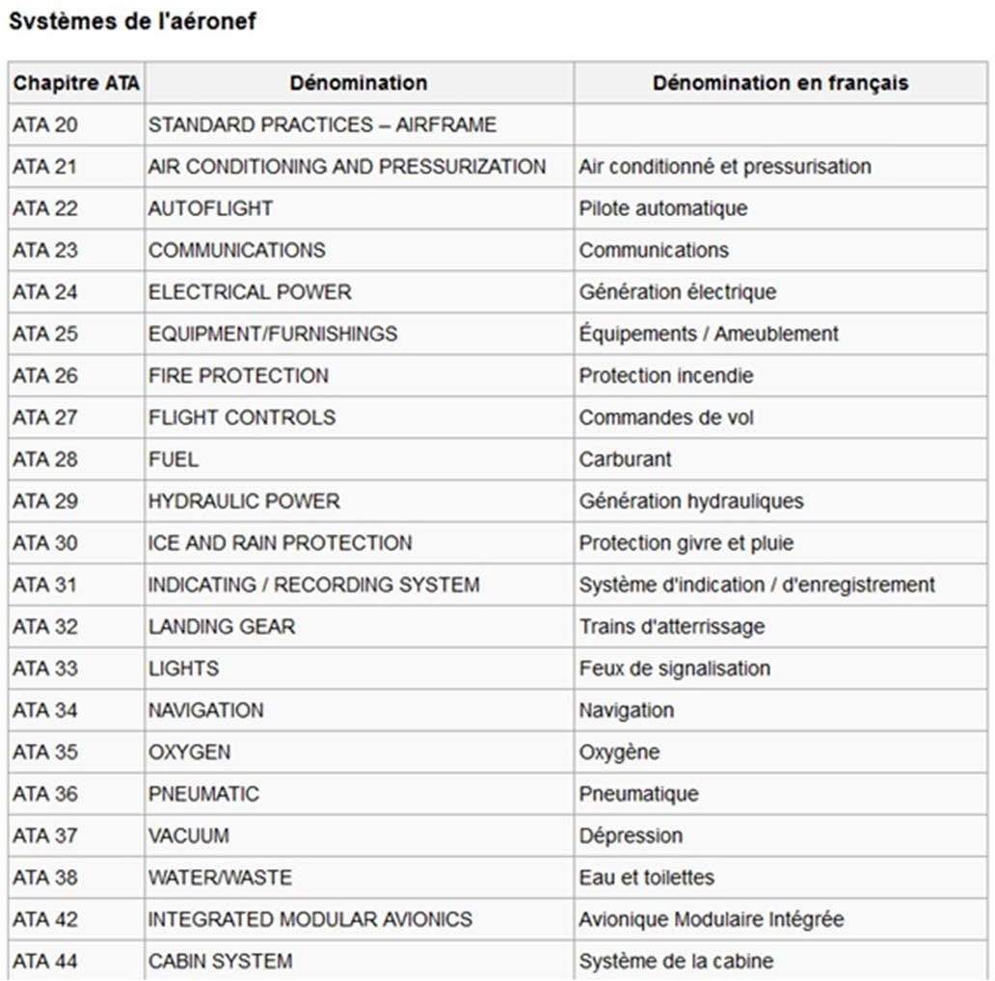

AMM: Aircraft Maintenance Manual IPC: Illustrated Parts Catalog PIPC: Power Plant Illustrated Parts TSM: Trouble Shooting Manual WDM: Wiring Diagram Manual ASM: Aircraft Schematic Manual AWM: Aircraft Wiring Manual AWL: Aircraft Wiring List
ESPM: Electrical Standard Pratices Manual

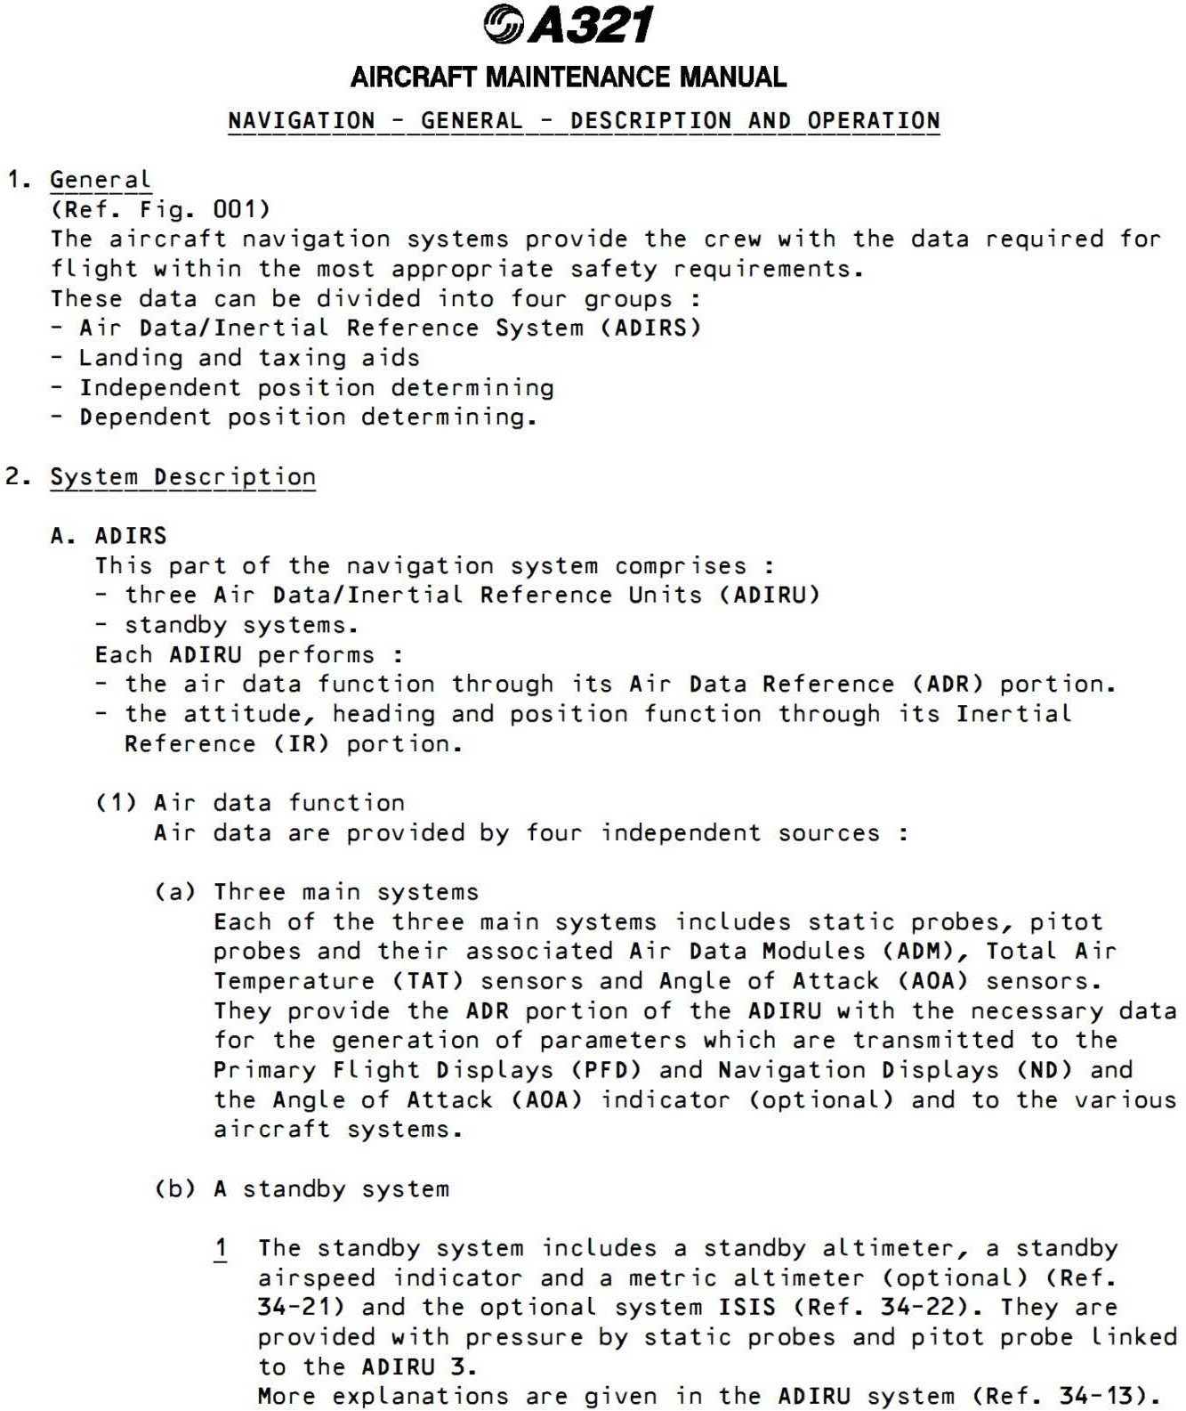

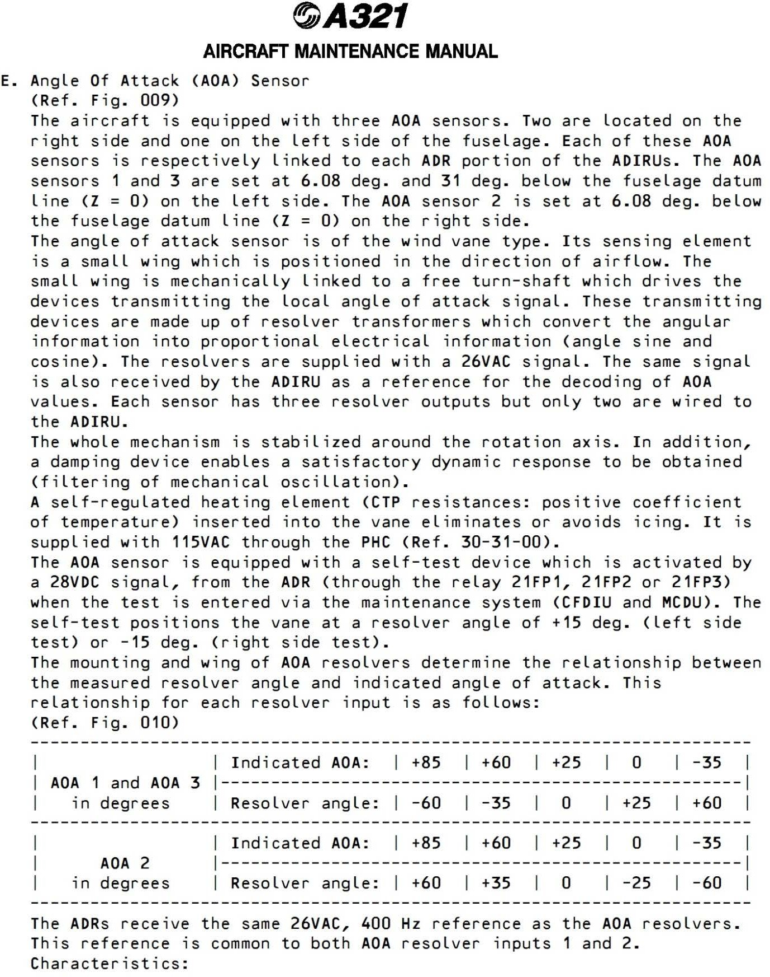

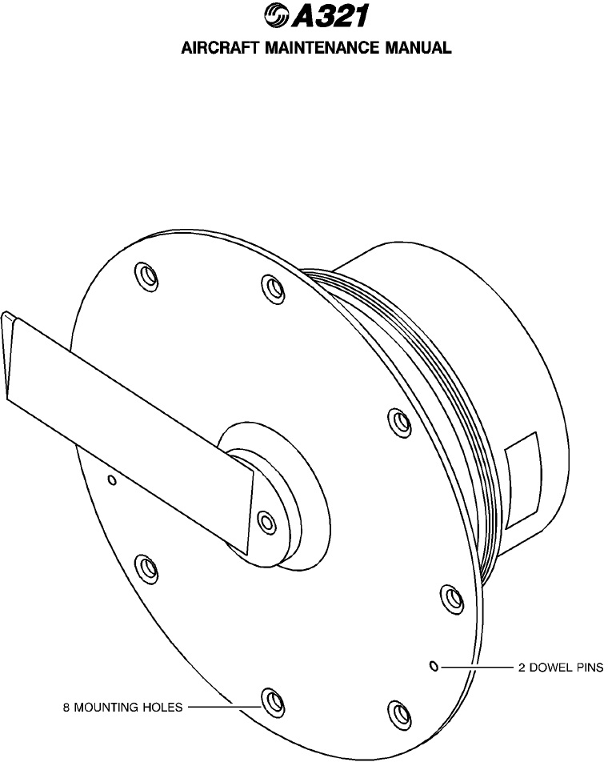

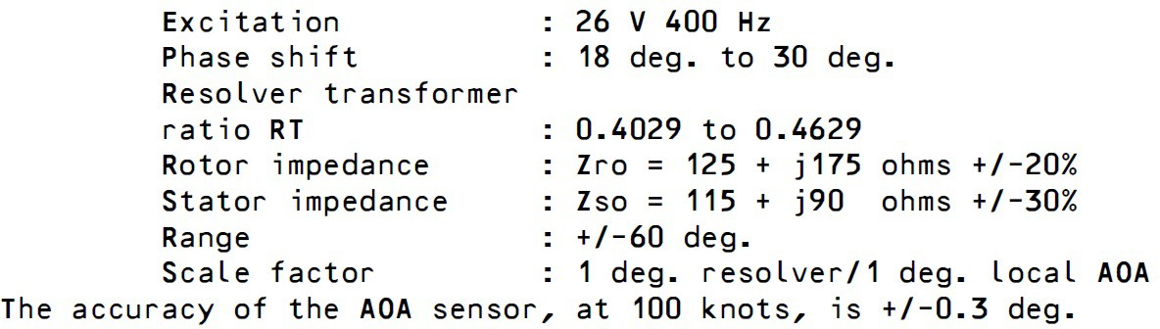

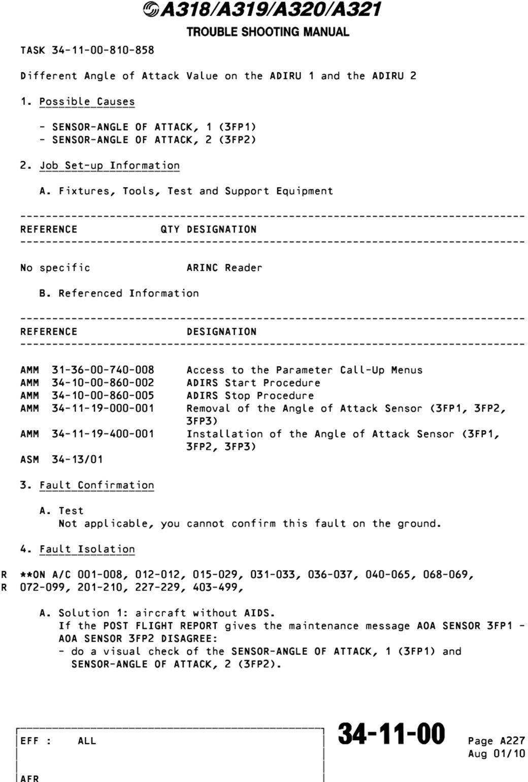

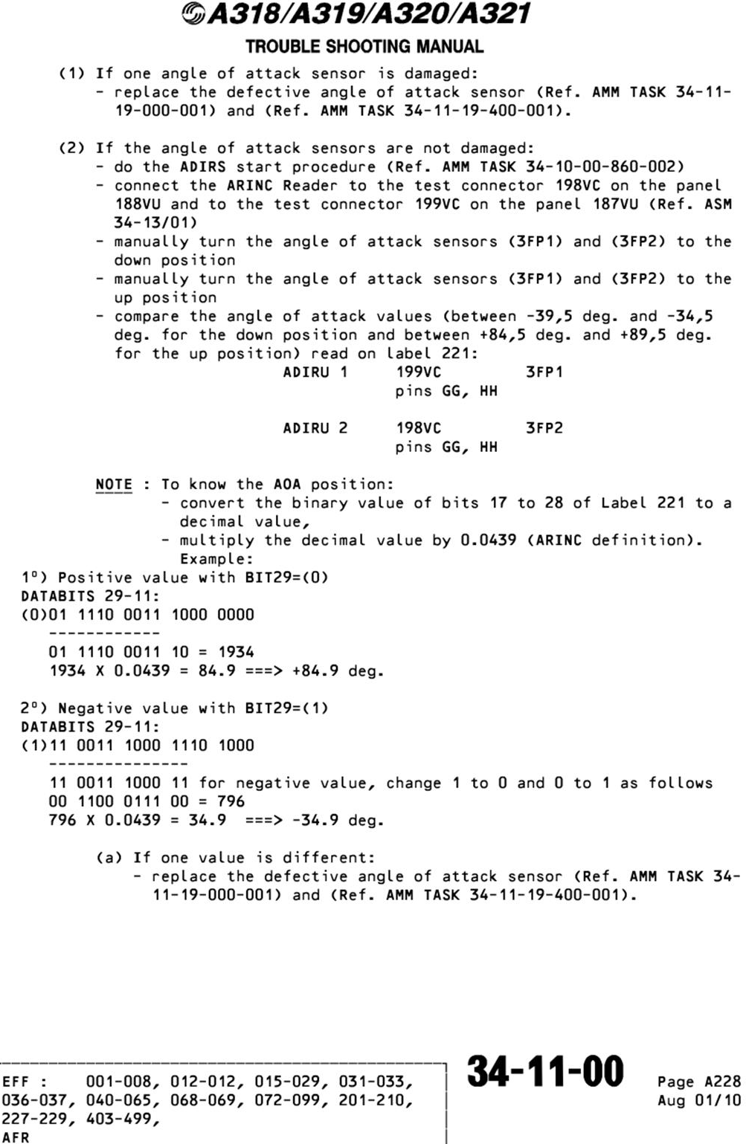

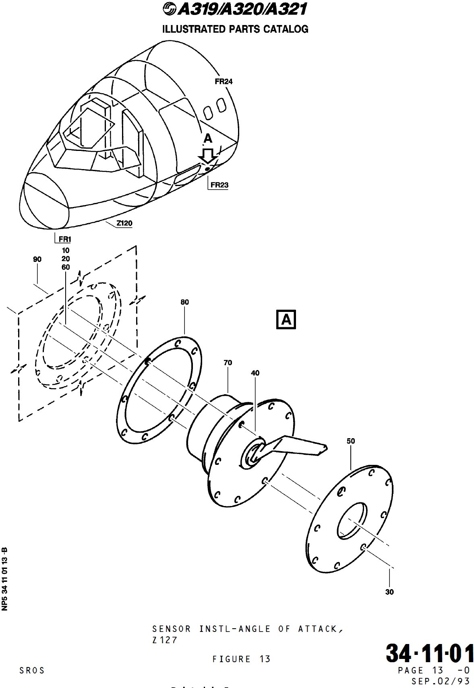

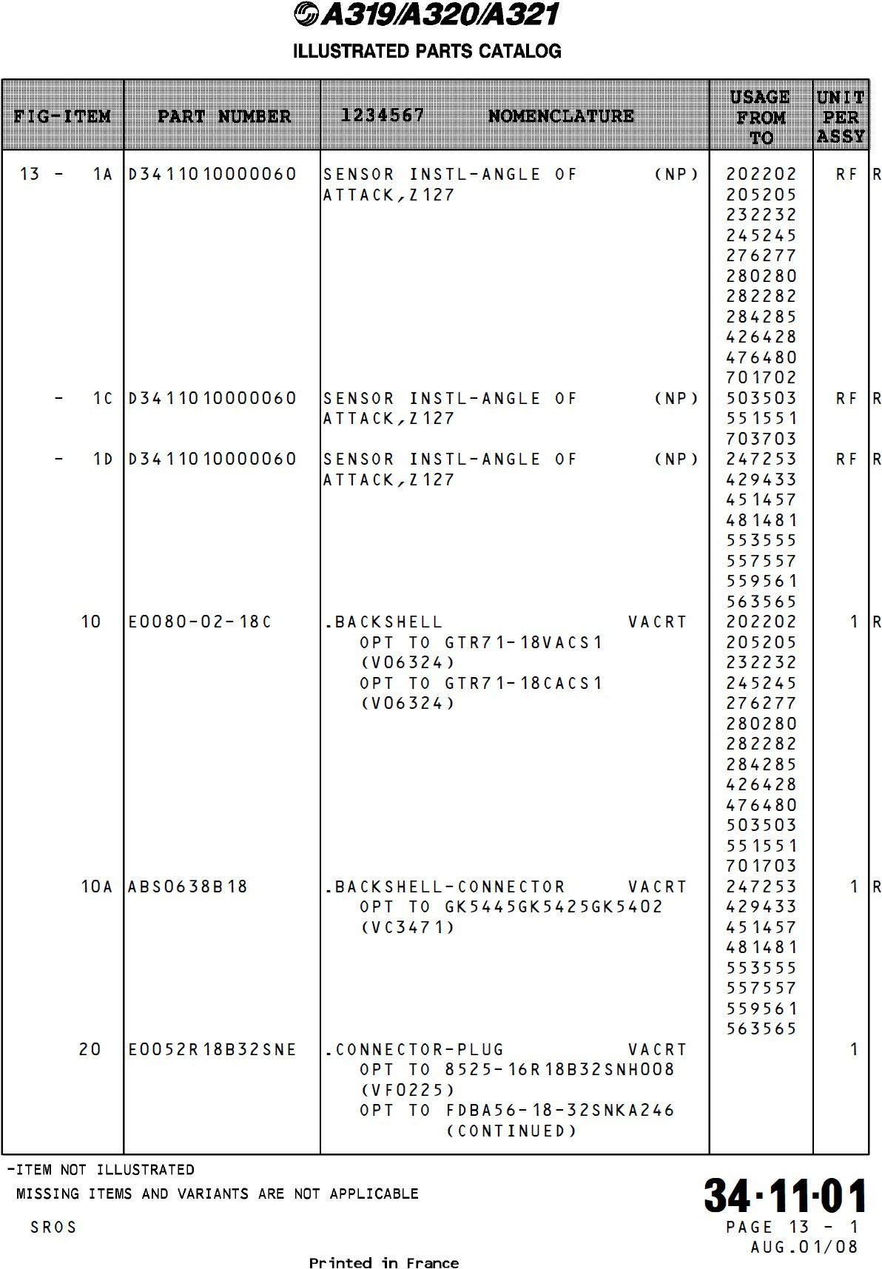

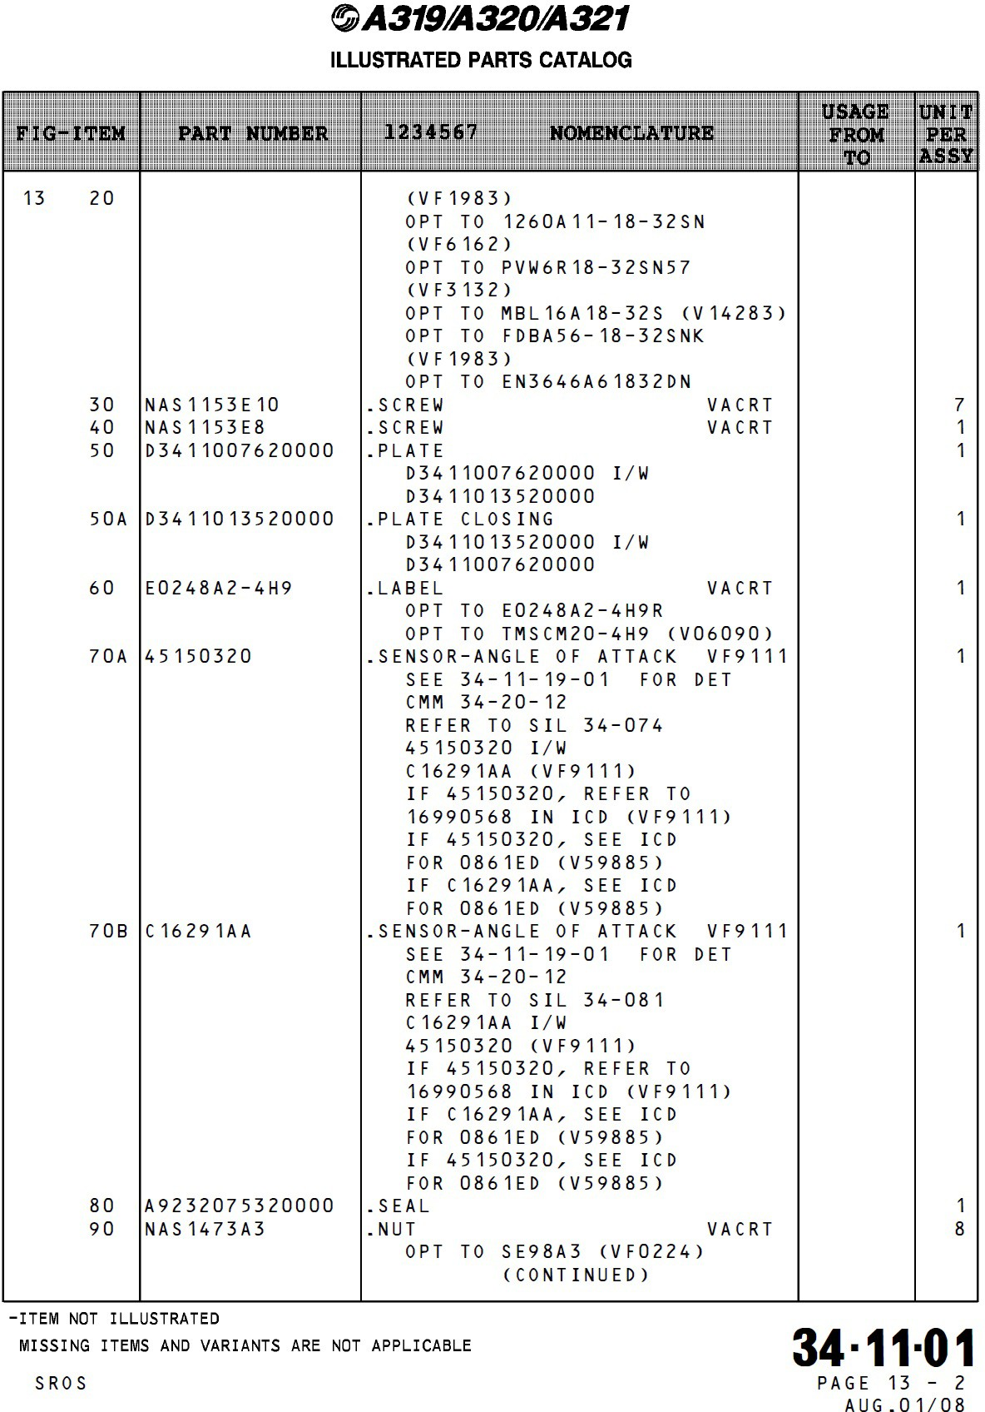

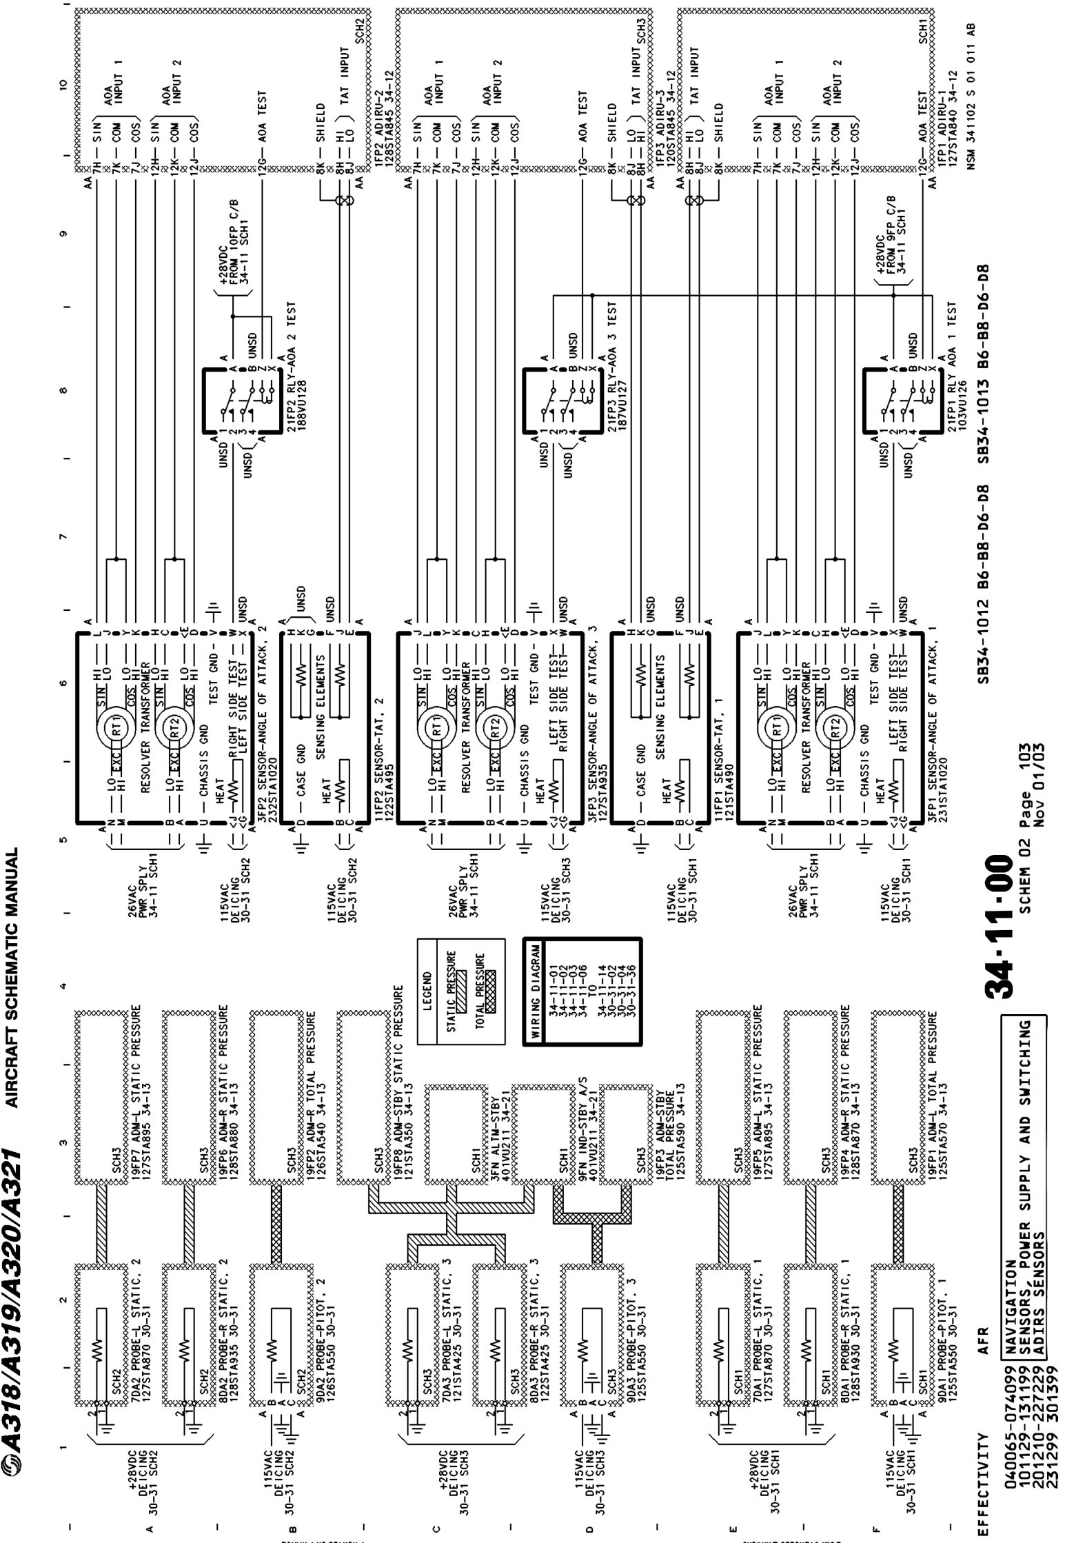

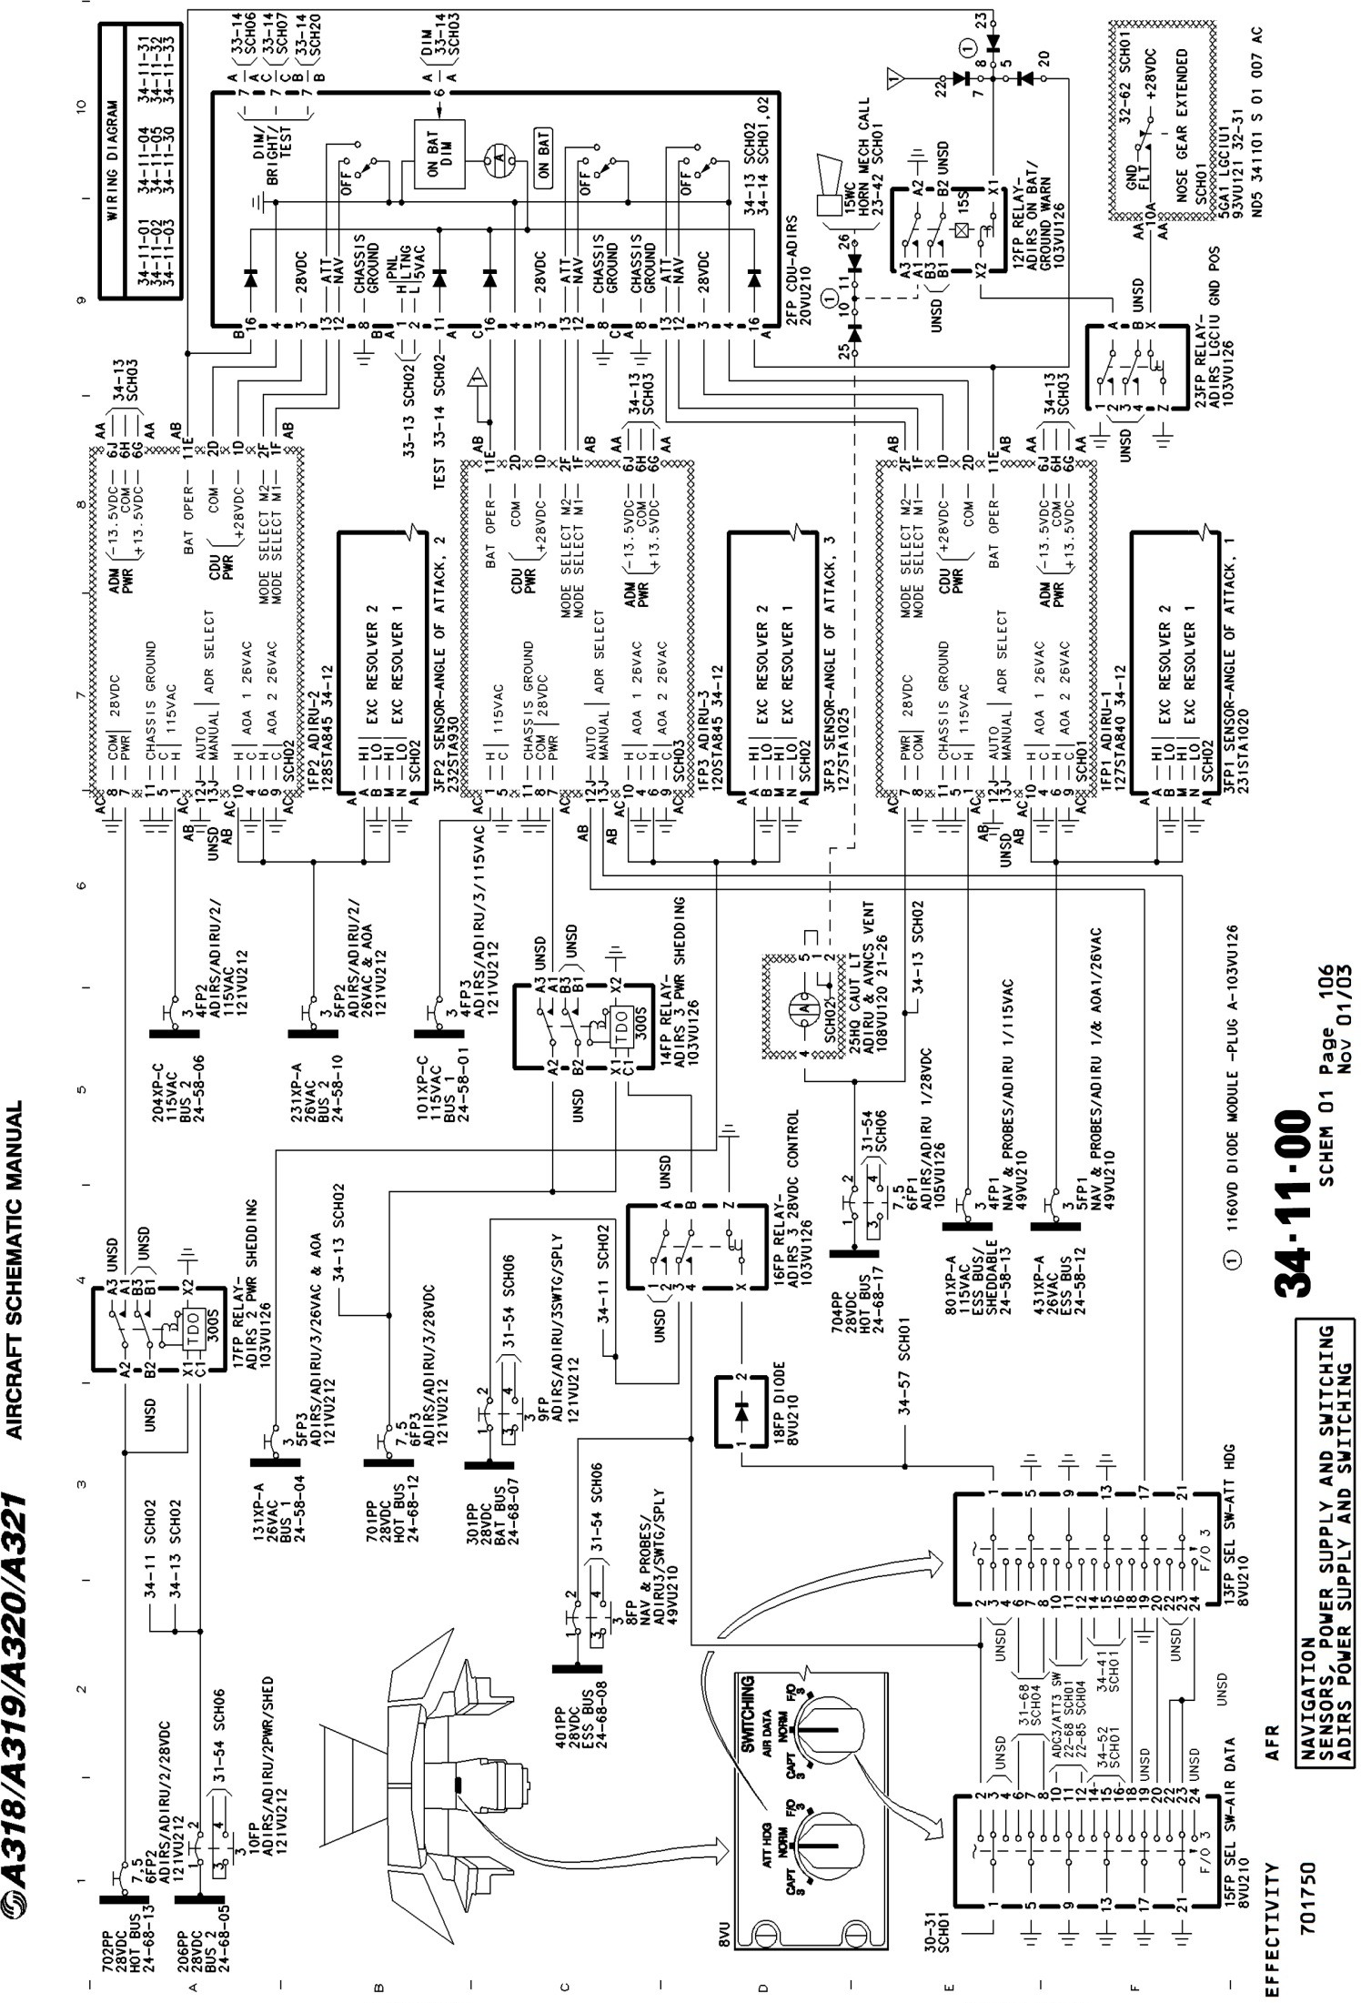

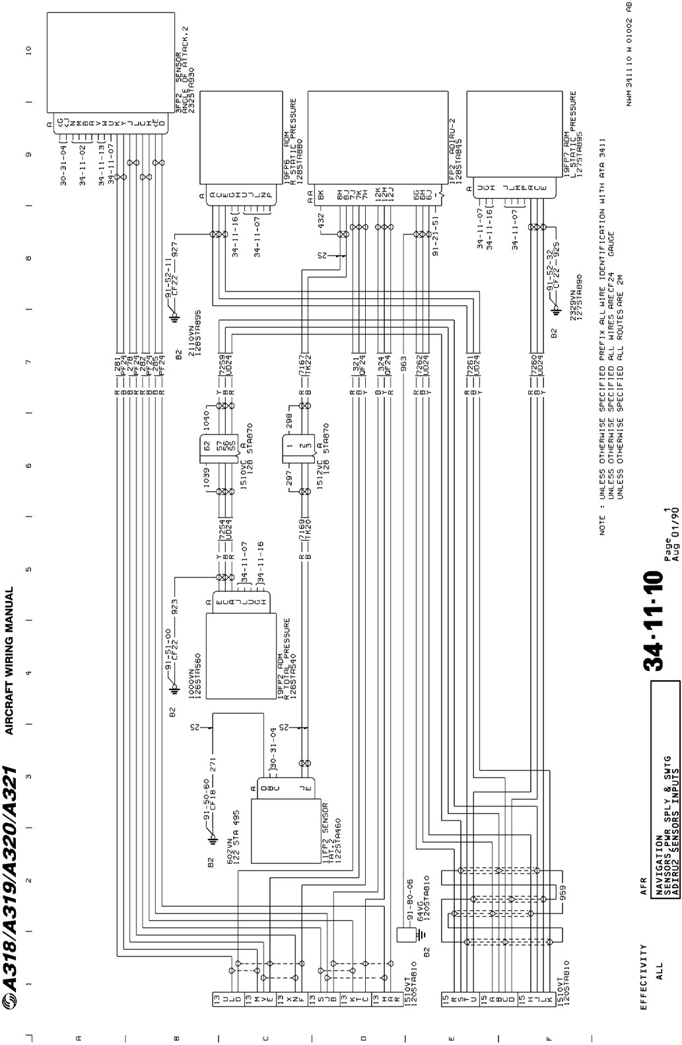

Caractéristiques des prises 8525

